**Online Vehicle Booking**

**Market Segmentation**

*By*

*Prem Kr Sah*

# Overview

The project, **Online Vehicle Booking Market Segmentation**, aims to help an Online Vehicle Booking Product Startup navigate the highly competitive Indian cab booking industry dominated by giants like Ola and Uber. The objective is to analyze the Indian vehicle booking market through segmentation analysis to identify profitable customer segments and develop a feasible strategy for market entry. The dataset used in this study consists of 131,662 records with 14 features, including Trip Distance, Type of Cab, Customer Loyalty (Customer_Since_Months), Lifestyle Index, Destination Type, Customer Ratings, Cancellation History, and Surge Pricing Type. These attributes provide valuable insights into customer preferences and booking patterns. The analysis was conducted using Python libraries such as numpy, pandas, seaborn, and matplotlib, with the **KMeans clustering algorithm** used to group customers into meaningful segments. A significant challenge faced during the project was cleaning the data, as the dataset contained numerous missing values and outliers. Overcoming these issues ensured reliable segmentation, enabling the identification of underserved segments where the startup can establish an early foothold and generate revenue.

# Problem Statement

The Indian cab booking market has experienced exponential growth in recent years, driven by increased urbanization, widespread internet penetration, and the popularity of mobile applications. However, this growth has also led to intense competition, with established players like Ola and Uber dominating the market. Their widespread presence and aggressive pricing strategies leave limited room for new entrants to thrive. For startups looking to enter this space, it becomes critical to identify unique opportunities that offer a competitive edge.

The challenge lies in understanding the dynamics of the market and uncovering untapped or underserved customer segments. It requires analysing customer preferences, behavioural patterns, and pain points to segment the market effectively. Additionally, recognizing factors like trip frequency, travel purpose, and customer loyalty can help define profitable niches for targeted marketing and service offerings.

This project aims to address these challenges by leveraging segmentation analysis of the Indian vehicle booking market. By analysing customer data and market trends, the objective is to discover actionable insights that can guide the startup's market entry strategy. The focus is to provide a clear roadmap for targeting the most promising segments, ultimately helping the startup establish a foothold in the highly competitive cab booking industry.

The insights derived from this analysis will enable the startup to develop tailored service offerings, pricing strategies, and marketing campaigns to meet the needs of specific customer groups, ensuring early adoption and sustainable revenue generation.

# Data Collection

For this project, the **"sigma_cabs.csv"** dataset was utilized to analyze and segment the online vehicle booking market. This dataset provides a rich set of attributes, capturing various aspects of trips and customer behavior. The columns include:

* **Trip_ID**: A unique identifier for each trip.
* **Trip_Distance**: The total distance travelled during the trip.
* **Type_of_Cab**: The category or type of cab selected by the customer.
* **Customer_Since_Months**: The number of months the customer has been associated with the service.
* **Life_Style_Index**: An index representing the customer’s lifestyle characteristics.
* **Confidence_Life_Style_Index**: A confidence measure for the lifestyle index.
* **Destination_Type**: The type or category of the destination for the trip.
* **Customer_Rating**: The rating provided by customers to evaluate their experience.
* **Cancellation_Last_1Month**: The count of trips cancelled by the customer in the last month.
* **Var1, Var2, Var3**: Additional variables providing insights into trip or customer-specific behavior.
* **Gender**: The gender of the customer.
* **Surge_Pricing_Type**: The surge pricing level applied to the trip.

This dataset serves as a robust foundation for exploring customer preferences, evaluating travel patterns, and identifying distinct market segments within the online vehicle booking space.

# Data Pre-Processing (Steps and Libraries Used)

The first step in data pre-processing involves importing the necessary libraries, which play a crucial role in preparing the data for analysis and modelling. Below is the code for importing the required libraries:

**Explanation of Libraries Used**

1. **Numpy**:
   * Used for performing mathematical and numerical computations.
   * It helps handle arrays, perform matrix operations, and manage numerical data efficiently.
2. **Pandas**:
   * A versatile library used for data manipulation and analysis.
   * Essential for loading, cleaning, and organizing the dataset into a structured format (Data Frames).
3. **Matplotlib**:
   * A robust library for data visualization.
   * It is utilized to create various types of static, interactive, and publication-quality plots, such as line plots, bar charts, and scatter plots.
4. **Seaborn**:
   * A data visualization library built on top of Matplotlib.
   * It simplifies the process of creating aesthetically pleasing and informative visualizations, such as heatmaps, pair plots, and box plots.
5. **Scikit-learn (sklearn.cluster.KMeans)**:
   * The KMeans module is specifically used for implementing the K-Means clustering algorithm.
   * Features like the sample_weight parameter allow assigning different weights to samples, which influences the computation of cluster centres and inertia values.

These libraries together form the backbone of the data pre-processing pipeline, enabling seamless handling of the dataset, insightful visualizations, and efficient implementation of the K-Means clustering algorithm.

# Segment Extraction

To identify meaningful customer segments in the dataset, clustering algorithms were employed.

**Libraries Used**

1. **Scikit-learn (KMeans and AgglomerativeClustering)**:
   * **KMeans**:
     + Implements the K-Means clustering algorithm, which partitions data into a predefined number of clusters by minimizing the sum of squared distances between data points and their assigned cluster centroids.
     + Offers features like centroid initialization, sample weighting, and flexibility in selecting the number of clusters (n_clusters).
   * **AgglomerativeClustering**:
     + A hierarchical clustering algorithm that builds clusters by merging or splitting them iteratively.
     + Provides options to define the linkage criteria (e.g., single, complete, average) and allows for visualization of hierarchical relationships.
2. **Scipy (distance_matrix and linkage)**:
   * **distance_matrix**:
     + Computes pairwise distances between points in the dataset, enabling analysis of proximity and relationships between data points.
   * **linkage**:
     + Used to perform hierarchical clustering by calculating linkages (e.g., single, complete, or average) based on the distance matrix.
   * **dendrogram**:
     + Visualizes the hierarchical structure of clusters in a tree-like diagram, helping to identify the optimal number of clusters and understand relationships between them.

**Advantages of the Approach**

* **Flexibility**: Both K-Means and hierarchical clustering methods allow for diverse segment extraction strategies tailored to the dataset's characteristics.
* **Scalable**: K-Means efficiently handles large datasets, while Agglomerative Clustering captures relationships effectively for smaller to moderately sized datasets.
* **Intuitive Visualization**: Dendrograms provide an intuitive way to explore hierarchical relationships and decide on the number of clusters.

# Exploratory Data Analysis

The Exploratory Data Analysis (EDA) phase was crucial for gaining a comprehensive understanding of the dataset and identifying key patterns, trends, and anomalies. Below is a detailed breakdown of the steps conducted during this analysis:

**4.1 Dataset Overview**

The dataset used contains information on customer behavior, trip details, and various attributes influencing pricing and customer satisfaction.

* **Shape of Dataset**: The dataset contains 131662 rows and 14 columns.
* **Column Data Types**:
  + Numerical: Trip_Distance, Life_Style_Index, Customer_Since_Months, Customer_Rating, Cancellation_Last_1Month, Var1, Var2, Var3, and Surge_Pricing_Type.
  + Categorical: Type_of_Cab, Destination_Type, Gender, and Confidence_Life_Style_Index.
* 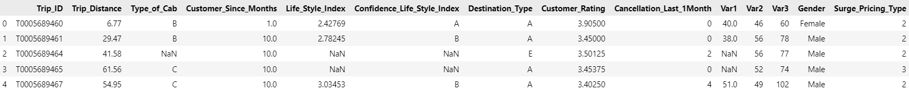**Initial Data Snapshot**:

**4.2 Descriptive Statistics**

Summary statistics were computed to provide a holistic view of numerical variables, helping to identify ranges, central tendencies, and variability.

Key insights:

From the descriptive statistics provided, the following key insights can be derived:

1. **Trip Distance**:
   * The average trip distance is approximately **44.20 units**, with a minimum of **0.31 units** and a maximum of **109.23 units**.
   * 50% of trips are shorter than **38.20 units**, while the top 25% of trips are longer than **60.73 units**, indicating a mix of short and long trips.
2. **Customer Since Months**:
   * Customers have been associated with the service for an average of **6.02 months**, with a maximum of **10 months**.
   * A significant number of customers are relatively new, as seen in the 25th percentile value of **3 months**.
3. **Life Style Index**:
   * The Life Style Index has an average value of **2.80**, with a tight standard deviation of **0.23**, indicating consistency in lifestyle preferences across the customer base.
   * The minimum and maximum values range from **1.59** to **4.87**, suggesting varying levels of lifestyle scores among customers.
4. **Customer Rating**:
   * The average customer rating is **2.85**, with ratings ranging from **1.00** to the maximum possible score of **5.00**.
   * A median score of **2.89** shows that most customers provide moderate ratings.
5. **Cancellations in the Last Month**:
   * The average number of cancellations in the last month is **0.78**, with most customers having minimal cancellations (25th percentile: **0.00**).
6. **Var1, Var2, and Var3**:
   * **Var1** has a mean of **64.20** and a high variability (std: **21.82**), while **Var2** and **Var3** show less spread in their values with means of **51.20** and **75.10**, respectively.
   * **Var3**, with a max of **206**, suggests the presence of some outliers or high-value cases.
7. **Surge Pricing Type**:
   * The surge pricing type has an average value of **2.16**, with a maximum of **3**, indicating that surge pricing is frequently applied, likely based on demand scenarios.

**4.3 Data Distribution Analysis**

The distributions of key numerical variables were visualized to identify patterns, skewness, and possible outliers.

*(Insert image: Histograms or KDE plots for numerical columns like Trip_Distance, Customer_Rating)*

Observations:

* The Trip_Distance variable exhibits a right-skewed distribution, indicating that shorter trips are more common.
* Customer ratings are predominantly high, suggesting positive overall feedback.

**4.4 Outlier Detection**

Boxplots were created to identify outliers in numerical variables such as Var1 and Life_Style_Index.

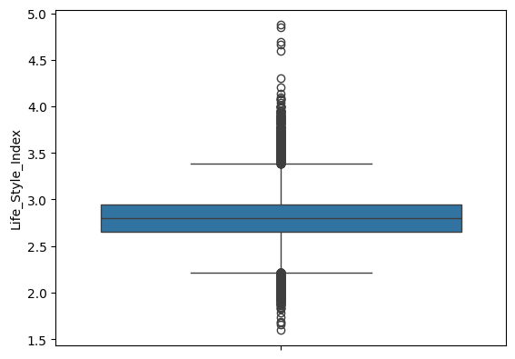

*Fig: Life_Style_Index Boxplot*

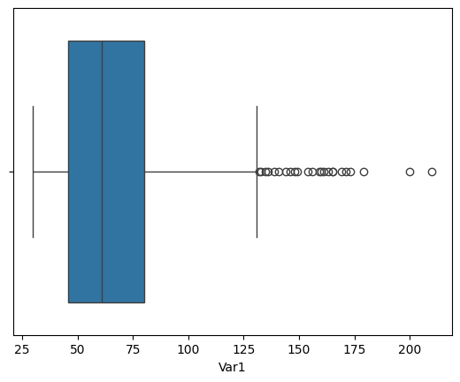

*Fig: Var1 Boxplot*

Findings:

* A few outliers were identified in **Life_Style_Index** and **Var1**, with values in both features deviating significantly from the rest of the data.
* Decisions on handling outliers were based on their potential impact on the clustering results. Outliers that could distort clustering were managed using median imputation, while those with minimal impact were left for further consideration or exclusion if necessary.

**4.5 Correlation Analysis**

A correlation matrix was computed to evaluate relationships between numerical variables.

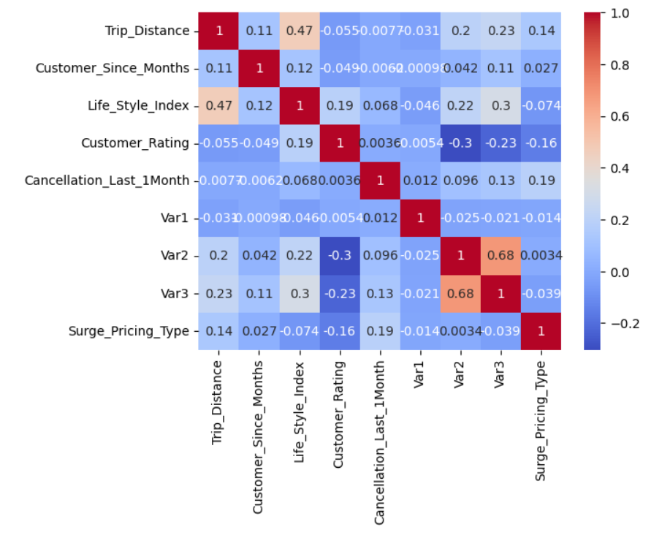

Key Correlations:

* **Trip_Distance and Surge_Pricing_Type** showed a moderate positive correlation (0.136), suggesting that longer trips are more likely to incur surge pricing.
* **Type_of_Cab and Surge_Pricing_Type** exhibited a moderate positive correlation (0.503), indicating that certain cab types may be more prone to surge pricing.
* Weak correlations between **Life_Style_Index** and other features suggest minimal direct influence. The highest correlation (0.119) was with **Customer_Since_Months**, which is still relatively weak.

**4.6 Pairwise Relationships**

Pair plots were created to visualize relationships between key variables such as Trip_Distance, Customer_Rating, and Life_Style_Index.

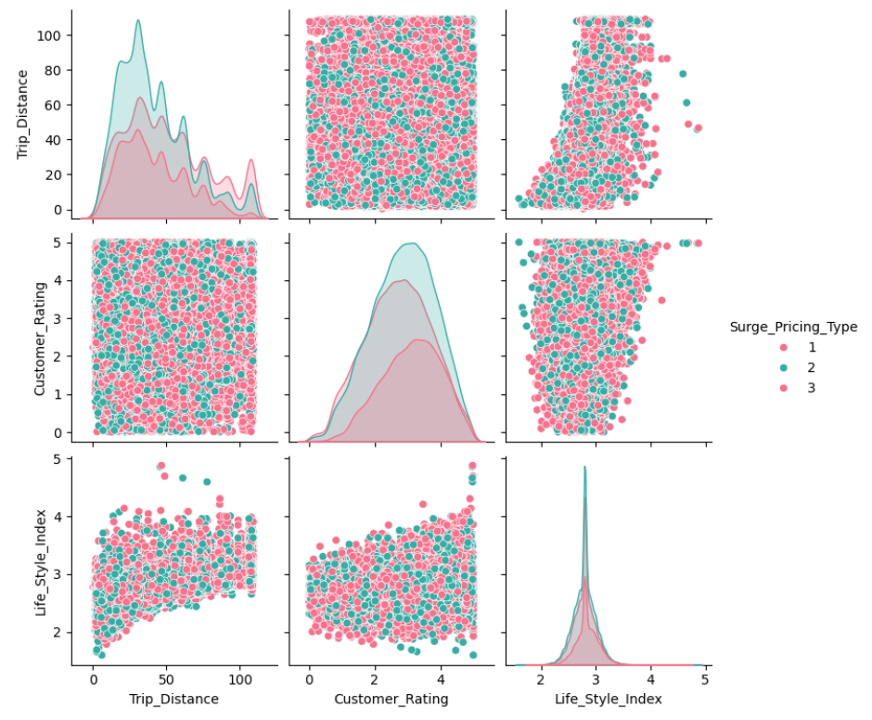

Insights:

* Higher-rated trips generally correspond to moderate trip distances, as seen from the scatter plot between Trip_Distance and Customer_Rating.
* Variations in Surge_Pricing_Type is evident, particularly in trips with longer distances, indicating that pricing is influenced by trip length.
* A clustering pattern is observed in the Life_Style_Index across all Surge_Pricing_Type categories, with minimal variation.

**4.7 Categorical Data Analysis**

The distribution of categorical variables such as Confidence_Life_Style_Index, Type_of_Cab, Destination_Type, and Gender was analyzed.

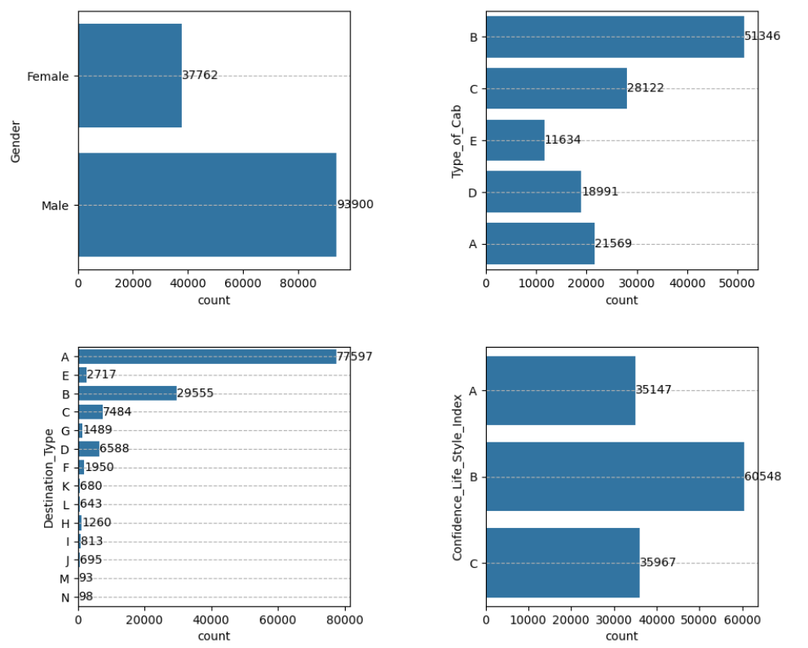

Highlights:

* The majority of trips were made using **economy cabs (Type B)**, followed by **compact cabs (Type C)**.
* Male customers outnumbered female customers, with approximately **93,900 trips by males** compared to **37,762 trips by females**, indicating a gender disparity in participation.
* Most trips had **Destination Type A**, far exceeding other destinations, indicating a clear preference or demand for this specific destination.
* In terms of confidence in the **Life_Style_Index**, Type B customers dominated, followed by Type C and Type A.

**4.8 Missing Data Analysis**

Missing values were visualized and handled appropriately.

**Actions Taken:**

* **Numerical Features**:
  + For features with missing numerical values, such as **Trip_Distance**, **Life_Style_Index**, **Var1**, and **Customer_Since_Months**, the distribution was analyzed using boxplots to determine the presence of outliers.
  + Due to the presence of significant outliers in some of these numerical features, **median imputation** was used to fill missing values.
* **Categorical Features**:
  + For categorical features with missing values, such as **Type_of_Cab** and **Confidence_Life_Style_Index**, the **mode imputation** technique was applied.

**4.9 Insights from EDA**

1. Trips with higher surge pricing are often longer and utilize **premium cabs**. However, the majority of trips are made using **economy cabs**, indicating that affordability is a significant factor for customers.
2. Customer ratings are skewed toward higher scores, suggesting good service quality overall. Higher-rated trips tend to correspond to **moderate trip distances**, as shown in the pair plot analysis.
3. **Gender participation is imbalanced**, with male customers taking significantly more trips than female customers.
4. Lifestyle indices do not strongly influence trip costs or surge pricing, indicating these features may play a secondary role in segmentation. However, customers with a **Type B Lifestyle Index** dominate the dataset, suggesting a potential trend in user behaviour
5. Most trips are directed to **Destination Type A**, far exceeding other destinations, highlighting a high demand or preference for this specific location.

This thorough EDA helped in identifying important trends and preparing the dataset for segmentation. The visualizations provided key insights that guided the choice of clustering algorithms and preprocessing steps.

# 6. K Means Clustering

K-Means Clustering is an unsupervised learning algorithm used in machine learning and data science for clustering problems. It automatically groups unlabeled data into distinct clusters based on similarities. The algorithm minimizes the distances between data points and their respective cluster centroids. It requires a predetermined number of clusters, denoted as "k," and iteratively improves cluster assignments.

To implement K-Means Clustering, the data is pre-processed by handling missing values and encoding categorical variables. The Scikit-Learn library provides the K-Means Clustering model, which is used to generate an "elbow curve." The elbow curve helps determine the optimal number of clusters by identifying the point where additional clusters no longer significantly improve the model's performance.

## Codes

All the codes used in this project can be found on <https://github.com/SasukeUchiha7/market-segmentation>